Haptic Interface for Vehicular Touch Screens

Car Screen TPAD Driving simulation

【Main Content】:

Participants perform target acquisition and slider adjustment tasks under visual, visual + tactile and tactile feedback conditions

【Paper Found】:

1) The display with haptic feedback significantly reduces eyes-off-road time

2) Developed an interaction that can be done with little or no visual confirmation

3) A positive attitude to tactile feedback through questionnaires

【Two tactile feedback design principles】：

1. The first design principle was that the tasks should be achievable without visual feedback. That is, the haptic feedback should not only add to the affect of the experience, it should also clearly communicate enough information as to stand alone.
2. The second design principle was that the physics of the display should assist in completing the task. For example, a selection location should resist motion away from it, and a transition location should encourage motion through it.

【Experiments】：

Apparatus：TPAD+Ford VIRTTEX driving simulator

Note: The experiment did not place TPAD on the display screen of the car. There was a display screen at that position, but TPAD was placed on the side of the handlebar (see the paper for details)

Seeing Machines faceLAB ： Eye tracking system to track the driver's gaze

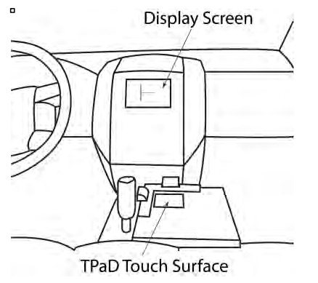 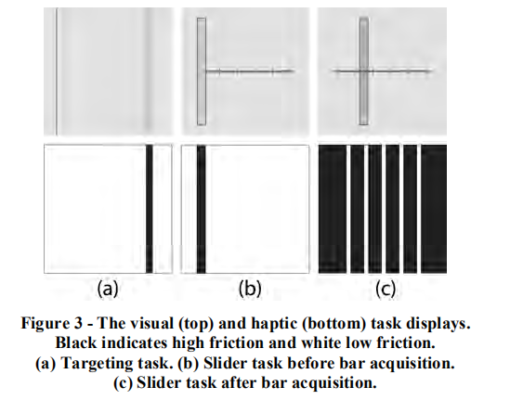

**Experiment 1: Get target-**The task is to "get" the target by sliding your finger into the target area. Instruct the subject to place their fingers anywhere on the screen, swipe left until they touch one side of the screen, then swipe right to get the target, and finally lift their fingers off the screen to indicate that they are finish.

**Experiment 2: Swipe screen (Such as menu selection)-** You can swipe left or right to any position with a gray tick. The user obtains the slider by sliding above it, and then the slider follows the finger until it is lifted from the screen, at which point the slider will capture the closest tick mark.

Discuss Results:

**1.Significance of Eyes Off Road Time:** By adding haptic feedback to other visual tasks on the touchpad, the driver can spend less time away from the road

**2. Performing Tasks Without Visual Feedback (in the case of haptic only):** Although the success rate is reduced for haptic only, users can perform tasks without any visual feedback. Although haptic success rates are better than random chances, the success rates for these tasks are particularly likely to be too low to be used in a driving environment.

**3.Subjective Response:** Most users are positive about the TPaD system as a whole

【NASA Task Questionnaire】：[20]

【Subjective analysis】：

**advantage:** Clearly divide driving tasks into 3 levels

Generally, user interaction tasks in the automotive environment can be divided into primary, secondary and tertiary tasks. The main tasks include maneuvering the vehicle in terms of acceleration and deceleration and steering. This task is of paramount importance to road safety and should therefore be brought to the attention of the operator. For example, secondary tasks are interaction with wipers and directional indicators and advanced driver assistance systems (ADAS), and they are also essential for road driving. All other security-unrelated functions are third-level interaction tasks. Many of these functions (such as entertainment, communications and information applications) are implemented in the in-vehicle information system (IVIS). The main requirement of IVIS is not to diversify the main tasks of the driver. Therefore, IVIS must not only meet universal usability standards, but it must also be suitable for driving tasks.

**Disadvantages:**

Lack of research on how long and how often drivers look at the screen

【Important Refrence】：

1. Bau, O., Poupyrev, I. Israr, A., Harrison, C. Teslatouch: electro-vibration for touch surfaces. Proc. UIST 2010 ACM Press (2010) 283-292.

7. Casiez, G., Roussel, N., Vanbelleghem, R., Giraud, F. Surfpad: riding towards targets on a squeeze film effect. CHI (2011): 2491-2500

8. Dai, X., Colgate, J.E., Peshkin, M.A., 2012. LateralPaD: A Surface-Haptic Device That Produces Lateral Forces on A Bare Finger. Haptics Symposium 2012, IEEE (2012), 7-14.

12. Grobart, Sam. Touch, Speak, Tap: Taking 5 Connected Cars for a Spin. NY Times (June 8, 2012).

13. Horrey, W., and Wickens, C. In-vehicle glance durations: Distributions, tails, and a model of crash risk. Trans. Research Record (2007), 22-28.

14. Immersion Corporation http://www.immersion.com/haptics-technology/haptics-in-use/automotive.html

15. Iwata, H., Yano, H., Nakaizumi, F., Kawamura, R. Project feelex: adding haptic surfact to graphics. Proc. UIST 2002 ACM (2002) 51-60.

17. Lévesque, V., Oram, L., MacLean, K., Cockburn, A., Marchuk, N., Johnson, D., Colgate, J.E., Peshkin, M.A. Enhancing physicality in touch interaction with programmable friction. Proc. CHI ‘11. ACM Press (2011), 2481-2490.

21. Pasquero, J., Hayward, V. Tactile feedback can assist vision during mobile interactions. Proc. CHI '11 ACM Press (2011) 3277-3280.